Jonathan Thorps

AWD1100 L01

The goal of this software is to administrate employee access in and around a facility or building. While gates, locks, and full time security guards is would certainly address this, having a software solution as another layer of security would streamline the giving and revoking access. An electronic locking system backed with software that can administrate these privileges is also a better solution than having to issue out numerous keys. Certain individuals would have unrestricted access while others will have a limited access. Individuals will be categorized by what division they belong to. Assignment to divisions would be permanent, while access privileges to different spaces can be modified as needed.

There will be a login function in which an administrator or security officer can login. The user will have the following functions:

* Login to software

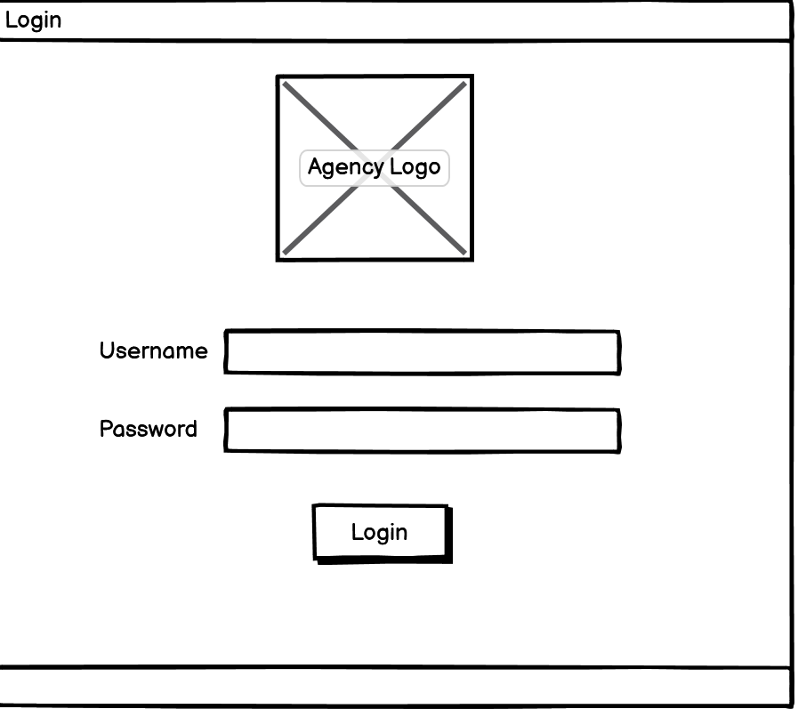

* Search employees

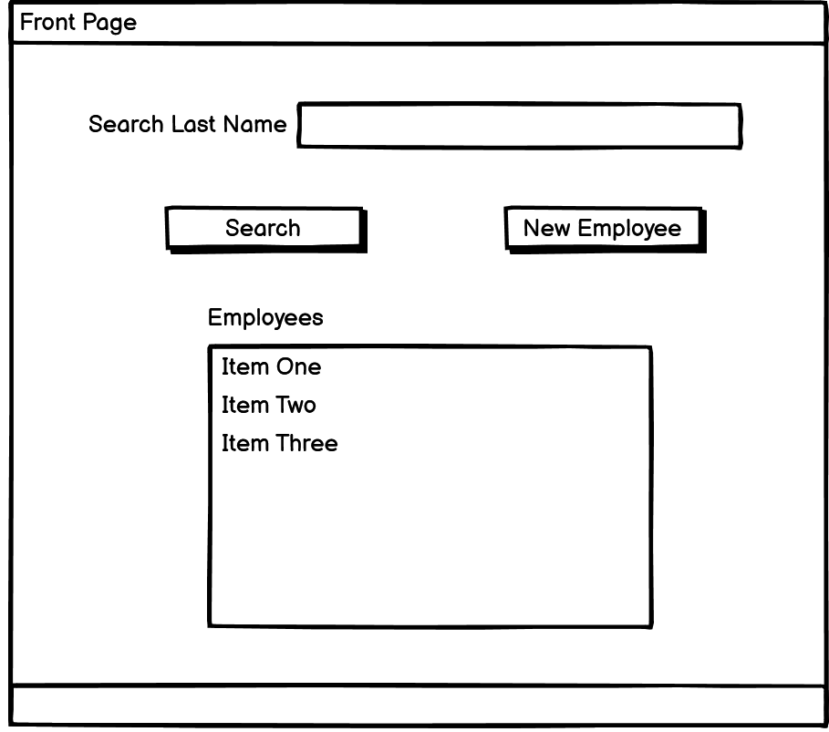

* Add employees
  + Adding new employees while generating a unique employee ID

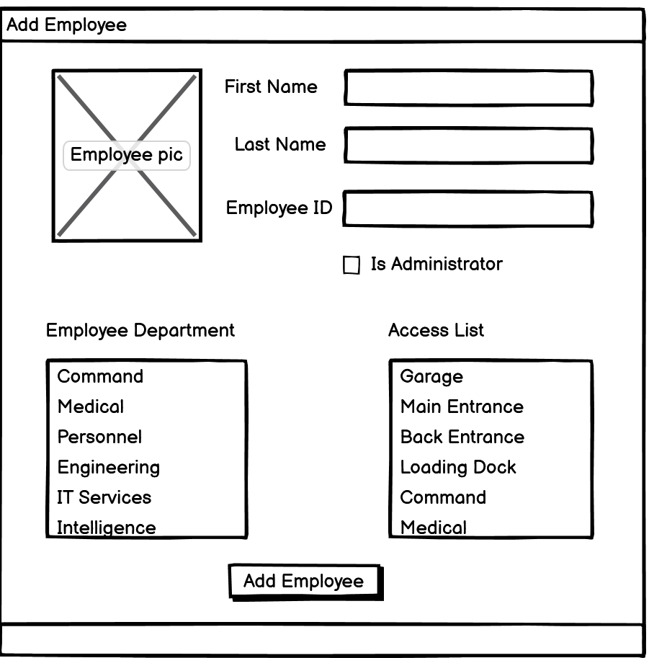

* Modify employee access privileges
* Delete employees

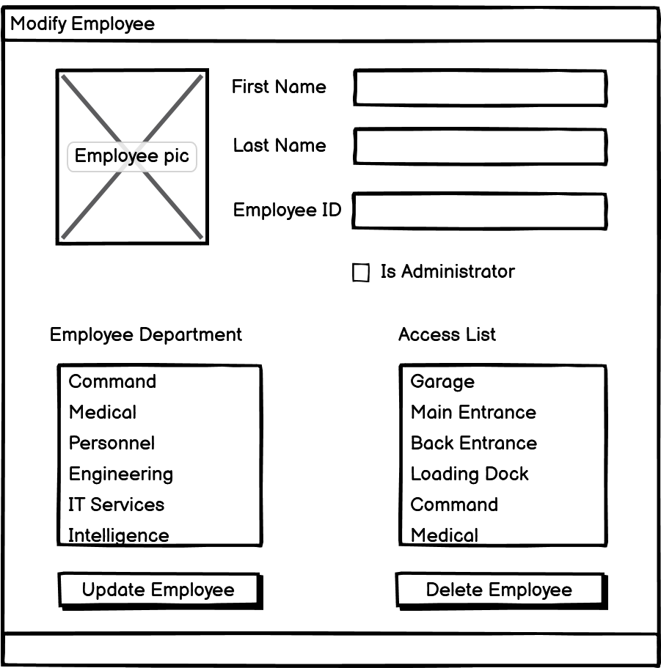

This type of software would be used in conjunction with a badge, RFID, and electronic lock system. Security officers would manage building access. Office space access would be divided into common spaces (i.e. library, cafeteria, conference room) and by division (Security, IT, Administration).

A software with similar capabilities is the security solution from Bosch.

<https://www.boschsecurity.com/us/en/solutions/access-control-systems/access-control-software/>

Their software can be scaled to a complete security suite integrating video surveillance and intrusion detection. Some of the available features are guest access, guard tour, and multi-factor authentication.

Smart Church Solutions also has a similar access control software.

<https://www.smartchurchsolutions.com/software/facility-system-integrations/access-control/>